Exercise 1 :

Mocking and Stubbing

Scenario:

You need to test a service that depends on an external API. Use Mockito to mock the

external API and stub its methods.

Steps:

1. Create a mock object for the external API.

2. Stub the methods to return predefined values.

3. Write a test case that uses the mock object.

**ExternalApi.java**

package com.example;

public interface ExternalApi {

String getData();

}

**MyService.java**

package com.example;

public class MyService {

private ExternalApi api;

public MyService(ExternalApi api) {

this.api = api;

}

public String fetchData() {

return api.getData();

}

}

**MyServiceTest.java**

package com.example;

import org.junit.jupiter.api.Test;

import static org.junit.jupiter.api.Assertions.assertEquals;

import static org.mockito.Mockito.*;

public class MyServiceTest {

@Test

public void testExternalApi() {

// Arrange

ExternalApi mockApi = mock(ExternalApi.class);

when(mockApi.getData()).thenReturn("Mock Data");

MyService service = new MyService(mockApi);

// Act

String result = service.fetchData();

// Assert

assertEquals("Mock Data", result);

}

}

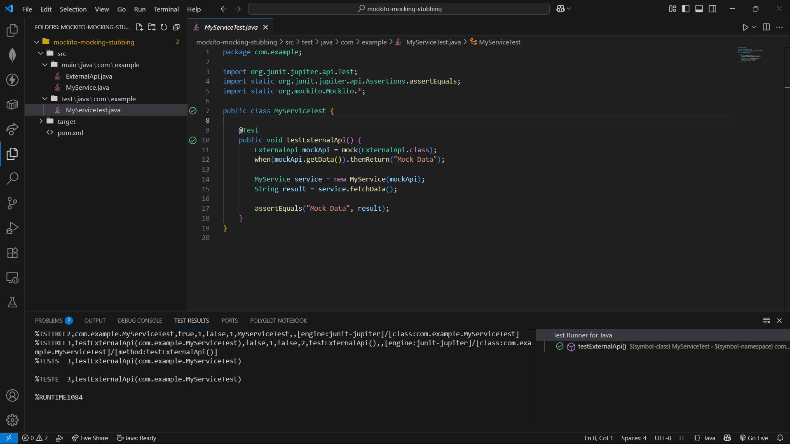

Exercise 2

Verifying Interactions

Scenario:

You need to ensure that a method is called with specific arguments.

Steps:

1. Create a mock object.

2. Call the method with specific arguments.

3. Verify the interaction.

**ExternalApi.java**

package com.example;

public interface ExternalApi {

String getData();

}

**MyService.java**

package com.example;

public class MyService {

private ExternalApi api;

public MyService(ExternalApi api) {

this.api = api;

}

public String fetchData() {

return api.getData();

}

}

**MyServiceTest.java**

package com.example;

import org.junit.jupiter.api.Test;

import static org.mockito.Mockito.*;

public class MyServiceTest {

@Test

public void testVerifyInteraction() {

// Arrange

ExternalApi mockApi = mock(ExternalApi.class);

MyService service = new MyService(mockApi);

// Act

service.fetchData();

// Assert (verify interaction)

verify(mockApi).getData(); // verifies method was called

}

}

pom.xml

<dependency>

<groupId>org.junit.jupiter</groupId>

<artifactId>junit-jupiter-api</artifactId>

<version>5.7.0</version>

<scope>test</scope>

</dependency>

<dependency>

<groupId>org.junit.jupiter</groupId>

<artifactId>junit-jupiter-engine</artifactId>

<version>5.7.0</version>

<scope>test</scope>

</dependency>

<dependency>

<groupId>org.mockito</groupId>

<artifactId>mockito-core</artifactId>

<version>3.6.0</version>

<scope>test</scope>

</dependency>

